Academic Year: 2026-27 Name of Student: Neev Rambhia
Semester: V Student ID: 25206010
Class / Div / Branch: T.E./ C / CSE(AI&ML) Roll No: 154
Subject: WMD Lab Date of Performance: 26/08/2026
Name of Instructor: Prof. Vijesh Nair Date of Submission: 09/09/2026

Experiment No. 4
Aim: Implement State Management using Hooks and Context API; add form handling and validation.
Lab Outcomes: Develop responsive front-end applications using React components and state management.
Software Used: Javascript, Nodejs, React
Program:
App.jsx:
import React from 'react';
import { BrowserRouter as Router, Routes, Route, Navigate } from 'react-router-dom';

import AppShell from './components/layout/AppShell';
import { CampusFixProvider, useCampusFix } from './context/CampusFixContext';

// Pages
import Dashboard from './pages/Dashboard';
import Issues from './pages/Issues';
import IssueDetails from './pages/IssueDetails';
import ReportIssue from './pages/ReportIssue';
import MyReports from './pages/MyReports';
import Announcements from './pages/Announcements';
import Help from './pages/Help';
import Analytics from './pages/Analytics';
import MaintenanceTeam from './pages/MaintenanceTeam';

import './index.css';

function AppContent() {
const {
dataSource,
setDataSource,
loadIssues,
searchTerm,
setSearchTerm
} = useCampusFix();

const handleToggleDataSource = () => {
if (dataSource === 'api') {
setDataSource('mock');
} else {
loadIssues();
}
};

return (
<Router>
<AppShell
dataSource={dataSource}
onToggleDataSource={handleToggleDataSource}
searchTerm={searchTerm}
onSearchChange={(e) => setSearchTerm(e.target.value)}
>
<Routes>
{/* Default Redirection */}
<Route path="/" element={<Navigate to="/dashboard" replace />} />

{/* Page 1: Dashboard Overview */}
<Route path="/dashboard" element={<Dashboard />} />

{/* Page 2: Issues Management */}
<Route path="/issues" element={<Issues />} />

{/* Page 2 Detail: Issue Details */}
<Route path="/issues/:id" element={<IssueDetails />} />

{/* Page 3: Report Issue */}
<Route path="/report" element={<ReportIssue />} />

{/* Page 4: My Reports */}
<Route path="/my-reports" element={<MyReports />} />

{/* Page 5: Announcements */}
<Route path="/announcements" element={<Announcements />} />

{/* Page 6: Help & Support */}
<Route path="/help" element={<Help />} />

{/* Page 7: Analytics */}
<Route path="/analytics" element={<Analytics />} />

{/* Optional Roster Route */}
<Route path="/maintenance-team" element={<MaintenanceTeam />} />

{/* Fallback 404 */}
<Route path="*" element={<Navigate to="/dashboard" replace />} />
</Routes>
</AppShell>
</Router>
);
}

export function App() {
return (
<CampusFixProvider>
<AppContent />
</CampusFixProvider>
);
}

export default App;
App.css:
.counter {
font-size: 16px;
padding: 5px 10px;
border-radius: 5px;
color: var(--accent);
background: var(--accent-bg);
border: 2px solid transparent;
transition: border-color 0.3s;
margin-bottom: 24px;

&:hover {
border-color: var(--accent-border);
}
&:focus-visible {
outline: 2px solid var(--accent);
outline-offset: 2px;
}
}

.hero {
position: relative;

.base,
.framework,
.vite {
inset-inline: 0;
margin: 0 auto;
}

.base {
width: 170px;
position: relative;
z-index: 0;
}

.framework,
.vite {
position: absolute;
}

.framework {
z-index: 1;
top: 34px;
height: 28px;
transform: perspective(2000px) rotateZ(300deg) rotateX(44deg) rotateY(39deg)
scale(1.4);
}

.vite {
z-index: 0;
top: 107px;
height: 26px;
width: auto;
transform: perspective(2000px) rotateZ(300deg) rotateX(40deg) rotateY(39deg)
scale(0.8);
}
}

#center {
display: flex;
flex-direction: column;
gap: 25px;
place-content: center;
place-items: center;
flex-grow: 1;

@media (max-width: 1024px) {
padding: 32px 20px 24px;
gap: 18px;
}
}

#next-steps {
display: flex;
border-top: 1px solid var(--border);
text-align: left;

& > div {
flex: 1 1 0;
padding: 32px;
@media (max-width: 1024px) {
padding: 24px 20px;
}
}

.icon {
margin-bottom: 16px;
width: 22px;
height: 22px;
}

@media (max-width: 1024px) {
flex-direction: column;
text-align: center;
}
}

#docs {
border-right: 1px solid var(--border);

@media (max-width: 1024px) {
border-right: none;
border-bottom: 1px solid var(--border);
}
}

#next-steps ul {
list-style: none;
padding: 0;
display: flex;
gap: 8px;
margin: 32px 0 0;

.logo {
height: 18px;
}

a {
color: var(--text-h);
font-size: 16px;
border-radius: 6px;
background: var(--social-bg);
display: flex;
padding: 6px 12px;
align-items: center;
gap: 8px;
text-decoration: none;
transition: box-shadow 0.3s;

&:hover {
box-shadow: var(--shadow);
}
.button-icon {
height: 18px;
width: 18px;
}
}

@media (max-width: 1024px) {
margin-top: 20px;
flex-wrap: wrap;
justify-content: center;

li {
flex: 1 1 calc(50% - 8px);
}

a {
width: 100%;
justify-content: center;
box-sizing: border-box;
}
}
}

#spacer {
height: 88px;
border-top: 1px solid var(--border);
@media (max-width: 1024px) {
height: 48px;
}
}

.ticks {
position: relative;
width: 100%;

&::before,
&::after {
content: '';
position: absolute;
top: -4.5px;
border: 5px solid transparent;
}

&::before {
left: 0;
border-left-color: var(--border);
}
&::after {
right: 0;
border-right-color: var(--border);
}
}

CampusFixContext.jsx:
import React, { createContext, useContext, useState, useEffect, useMemo } from 'react';
import { user as initialUser, mockIssues } from '../data/mockData';
import {
getIssues,
getIssue,
createIssue,
updateIssue,
patchIssue,
deleteIssue
} from '../services/issueService';

// 1. Create Context
export const CampusFixContext = createContext(null);

// 2. Provider Component
export function CampusFixProvider({ children }) {
// Application Data & Auth State
const [issues, setIssues] = useState([]);
const [currentUser, setCurrentUser] = useState(initialUser);
const [selectedIssue, setSelectedIssue] = useState(null);

// Search & Filter State
const [searchTerm, setSearchTerm] = useState('');
const [selectedCategory, setSelectedCategory] = useState('All');
const [selectedPriority, setSelectedPriority] = useState('All');
const [selectedStatus, setSelectedStatus] = useState('All');

// Status & Connectivity State
const [loading, setLoading] = useState(true);
const [error, setError] = useState(null);
const [dataSource, setDataSource] = useState('api'); // 'api' or 'mock'

// Load Issues Action (GET /issues)
const loadIssues = async () => {
setLoading(true);
setError(null);
try {
const data = await getIssues();
setIssues(data);
setDataSource('api');
} catch (err) {
console.warn('REST API unavailable. Falling back to mockData.js:', err.message);
setError('Unable to connect to CampusFix API. Showing cached mock data.');
setIssues(mockIssues);
setDataSource('mock');
} finally {
setLoading(false);
}
};

// Initial Load with useEffect
useEffect(() => {
loadIssues();
}, []);

// Action: Add Issue (POST /issues)
const addIssue = async (newIssueData) => {
setError(null);
try {
if (dataSource === 'api') {
const created = await createIssue(newIssueData);
setIssues((prev) => [created, ...prev]);
return created;
} else {
const fallback = { ...newIssueData, id: String(Date.now()) };
setIssues((prev) => [fallback, ...prev]);
return fallback;
}
} catch (err) {
console.error('API create issue failed:', err);
setError(`Failed to create issue on server: ${err.message}`);
const fallback = { ...newIssueData, id: String(Date.now()) };
setIssues((prev) => [fallback, ...prev]);
return fallback;
}
};

// Action: Update Issue (PUT /issues/:id)
const handleUpdateIssue = async (id, updatedIssueData) => {
try {
if (dataSource === 'api') {
const updated = await updateIssue(id, updatedIssueData);
setIssues((prev) => prev.map((item) => (String(item.id) === String(id) ? updated : item)));
if (selectedIssue && String(selectedIssue.id) === String(id)) {
setSelectedIssue(updated);
}
} else {
setIssues((prev) =>
prev.map((item) => (String(item.id) === String(id) ? { ...item, ...updatedIssueData } : item))
);
}
} catch (err) {
console.error('API update failed:', err);
setError(`Failed to replace issue: ${err.message}`);
}
};

// Action: Patch Issue (PATCH /issues/:id)
const handlePatchIssue = async (id, patchData) => {
try {
if (dataSource === 'api') {
const patched = await patchIssue(id, patchData);
setIssues((prev) =>
prev.map((item) => (String(item.id) === String(id) ? { ...item, ...patched } : item))
);
if (selectedIssue && String(selectedIssue.id) === String(id)) {
setSelectedIssue((prev) => ({ ...prev, ...patched }));
}
} else {
setIssues((prev) =>
prev.map((item) => (String(item.id) === String(id) ? { ...item, ...patchData } : item))
);
}
} catch (err) {
console.error('API patch status failed:', err);
setIssues((prev) =>
prev.map((item) => (String(item.id) === String(id) ? { ...item, ...patchData } : item))
);
}
};

// Action: Delete Issue (DELETE /issues/:id)
const handleDeleteIssue = async (id) => {
try {
if (dataSource === 'api') {
await deleteIssue(id);
}
setIssues((prev) => prev.filter((item) => String(item.id) !== String(id)));
if (selectedIssue && String(selectedIssue.id) === String(id)) {
setSelectedIssue(null);
}
} catch (err) {
console.error('API delete failed:', err);
setIssues((prev) => prev.filter((item) => String(item.id) !== String(id)));
}
};

// Fetch single issue details
const fetchSingleIssue = async (id) => {
try {
const issue = await getIssue(id);
setSelectedIssue(issue);
return issue;
} catch (err) {
console.warn(`Could not fetch issue #${id} from API, finding in local state:`, err.message);
const found = issues.find((i) => String(i.id) === String(id));
if (found) setSelectedIssue(found);
return found;
}
};

// Derived Filtered Issues (non-mutating)
const filteredIssues = useMemo(() => {
return issues.filter((issue) => {
const titleText = (issue.title || '').toLowerCase();
const descText = (issue.description || '').toLowerCase();
const locText = (issue.location || '').toLowerCase();
const reporterText = (issue.reporter || issue.reportedBy || '').toLowerCase();
const query = searchTerm.toLowerCase();

const matchesSearch =
!searchTerm ||
titleText.includes(query) ||
descText.includes(query) ||
locText.includes(query) ||
reporterText.includes(query);

const matchesCategory =
selectedCategory === 'All' || issue.category === selectedCategory;

const matchesPriority =
selectedPriority === 'All' || issue.priority === selectedPriority;

const matchesStatus =
selectedStatus === 'All' || issue.status === selectedStatus;

return matchesSearch && matchesCategory && matchesPriority && matchesStatus;
});
}, [issues, searchTerm, selectedCategory, selectedPriority, selectedStatus]);

// Dynamic Dashboard Statistics derived from issues state
const stats = useMemo(() => {
const totalIssues = issues.length;
const reportedIssues = issues.filter((i) => i.status === 'Reported').length;
const inProgressIssues = issues.filter((i) => i.status === 'In Progress').length;
const resolvedIssues = issues.filter((i) => i.status === 'Resolved').length;
const highPriorityIssues = issues.filter((i) => i.priority === 'High').length;

return {
totalIssues,
reportedIssues,
inProgressIssues,
resolvedIssues,
highPriorityIssues,
};
}, [issues]);

const value = {
// State Values
issues,
filteredIssues,
currentUser,
setCurrentUser,
selectedIssue,
setSelectedIssue,
searchTerm,
selectedCategory,
selectedPriority,
selectedStatus,
loading,
error,
dataSource,
stats,

// Actions & Setters
loadIssues,
addIssue,
updateIssue: handleUpdateIssue,
patchIssue: handlePatchIssue,
deleteIssue: handleDeleteIssue,
fetchSingleIssue,
setSearchTerm,
setSelectedCategory,
setSelectedPriority,
setSelectedStatus,
setDataSource,
};

return (
<CampusFixContext.Provider value={value}>
{children}
</CampusFixContext.Provider>
);
}

// Custom Hook to consume Context
export function useCampusFix() {
const context = useContext(CampusFixContext);
if (!context) {
throw new Error('useCampusFix must be used within a CampusFixProvider');
}
return context;
}

export default CampusFixContext;
Output:
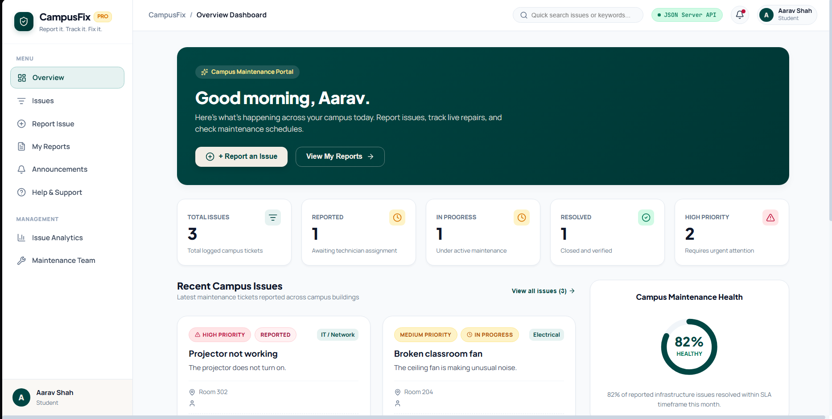
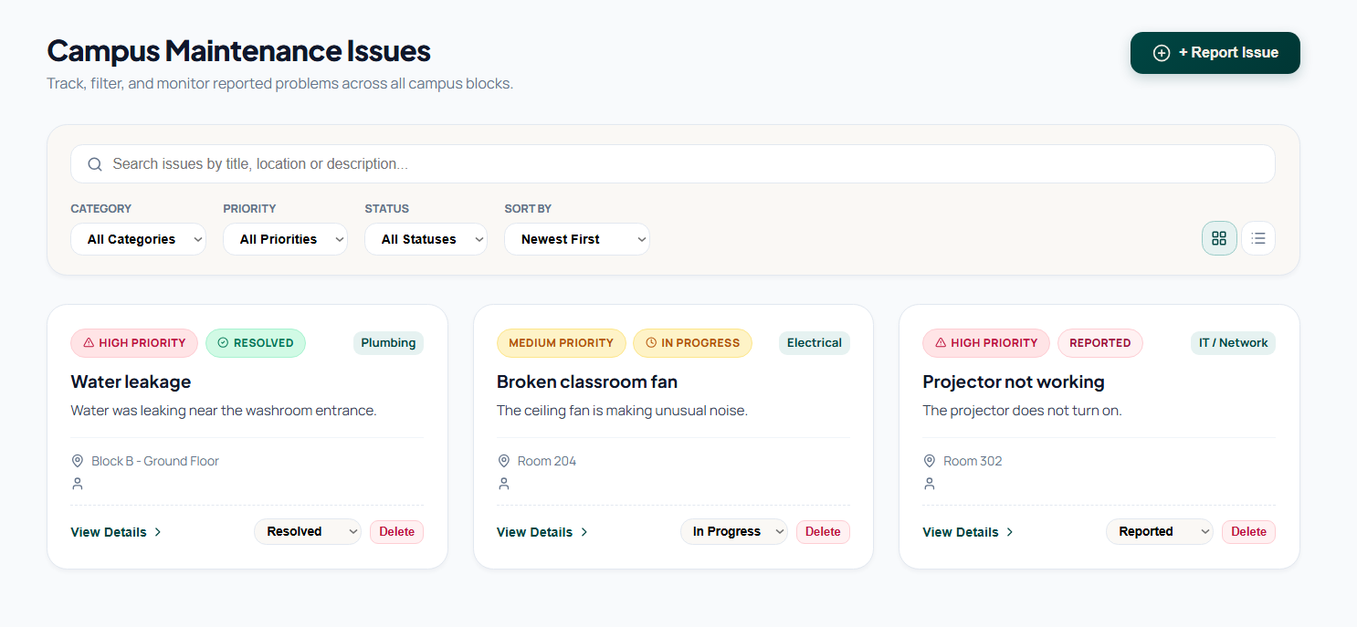
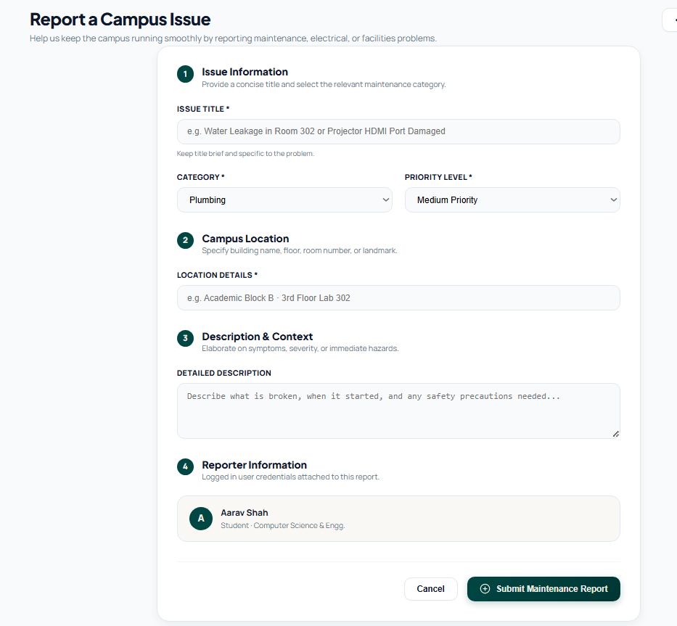
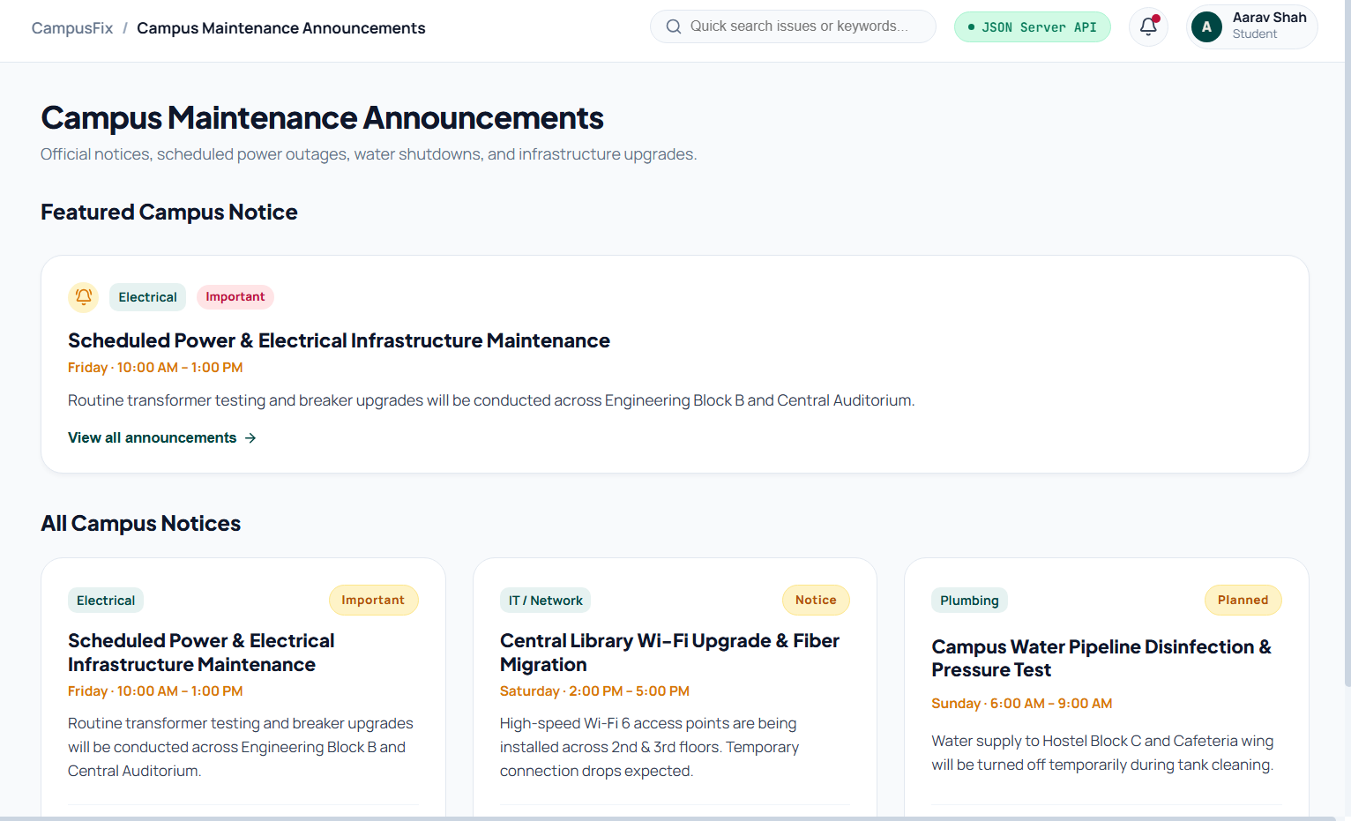
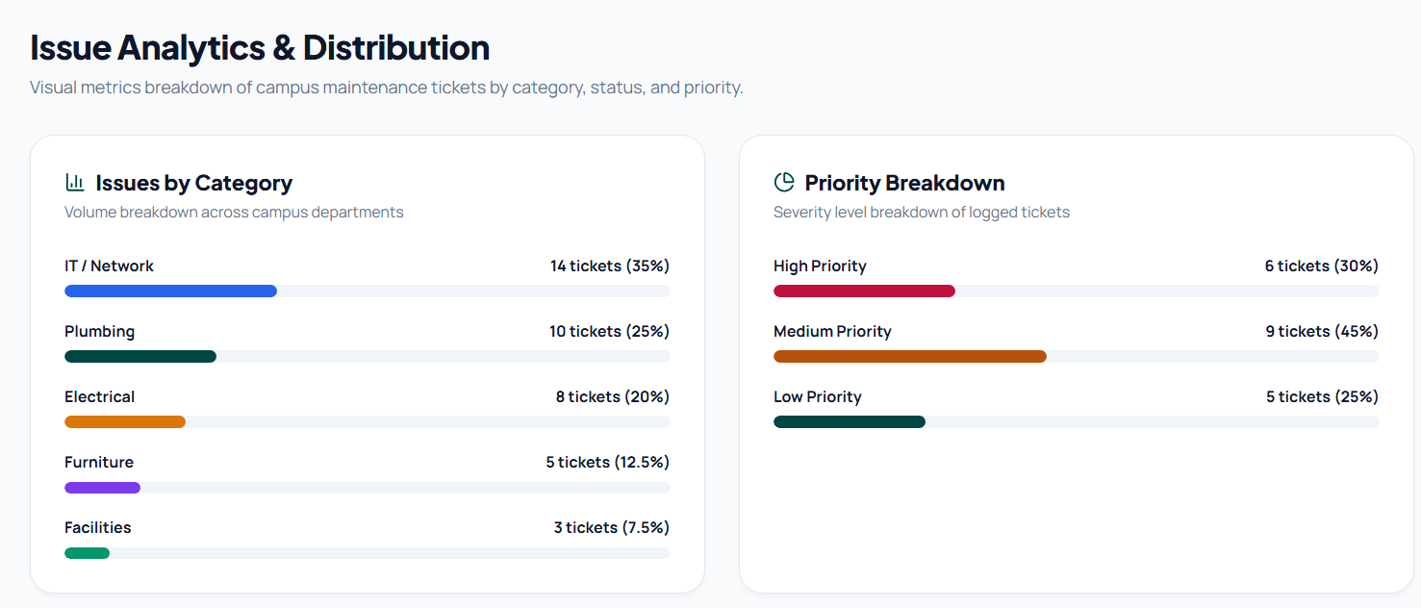
Conclusion: Thus, we have designed and implemented state management using Hooks and Context API; added form handling and validation.

